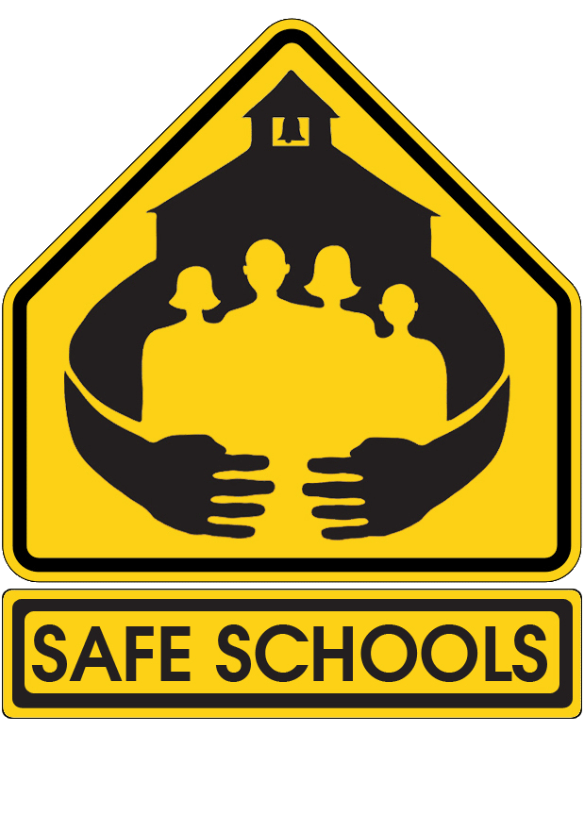 **Bullying or Harassment Investigation Checklist**

The school principal or designee is encouraged to adhere to the following checklist when conducting any investigation of bullying or harassment. By completing this checklist each time an investigation is conducted, we are able to better ensure a proper investigation was conducted. Administrators should take care to ask open-ended questions to enable students or employees to describe what happened in their own words. The principal or designee will ensure that each student or employee is accorded a safe and respectful environment in which to meet and that all parties will be interviewed separately.

|  |  |
| --- | --- |
| **Investigative Steps** | **Initials** |
| 1. A complaint of bullying or harassment is received by the appropriate school administrator or designee. Reports can be made face-to-face, via telephone, email, letter, or through our anonymous reporting system. |  |
| 1. Interview with complainant within 1 school day of receiving report (unless information was gathered at the time of the report). Interview should attempt to ascertain:  * Where did the incident(s) occur * When did the incident (s) occur * How was the victim bullied or harassed * Any witnesses to the incident(s) * Who reported the incident * Who was the victim * Who is the accused * Any pattern of behavior |  |
| 1. Interview the reported victim within 1 school day of the received report (unless initial report was made by the victim). Attempt to verify all information reported and determine whether the incident meets the standard for a school district incident of bullying and harassment, falls outside the scope of the district and needs to be reported to law enforcement (for criminal acts), or whether there is nothing to substantiate a continued investigation. If the incident falls within jurisdiction of the district and determined a criminal act, refer to appropriate law enforcement agency and do not proceed to investigation until proper clearance by law enforcement. If the incident is substantiated as bullying but outside jurisdiction of the district, and determined not a criminal act, inform parents/legal guardians of all students involved. Alleged acts of bullying or harassment committed while en route to school aboard a school bus or at a school bus stop fall within the jurisdiction of the school district. |  |
| 1. If the incident meets the standard for a continued investigation of bullying or harassment, contact the parents of the victim and any accused perpetrators within 24 hours of the onset of the investigation. For incidents that are reported as bullying, but which remain unsubstantiated after speaking with the reported victim, document the report in the SESIR system as Unsubstantiated Bullying (UBL). |  |
| 1. After the onset of the investigation, conduct ***separate*** interviews with any listed witnesses and the accused perpetrators. Have witnesses and accused complete written responses to the reported incident and accusations. |  |
| 1. The investigation shall be completed in no more than 10 school days. The highest level of confidentiality possible will be upheld regarding the submission of a complaint or a report of bullying and harassment, and the investigative procedures that follow. |  |
| 1. If the investigation reveals a violation of the Student Code of Conduct, apply all applicable interventions and consequences. The student’s history of aggressive acts and any bullying or harassment must be considered when determining any outcomes or dispositions. |  |
| 1. Take note of the seriousness of the impact on any victim of bullying and harassment and refer the student(s) to the school counselor for any follow-up services as necessary. Parents or legal guardians must be made aware of any counseling referrals. |  |
| 1. If necessary, create a safety plan for the student. Ensure the plan includes the separation of the victim and any alleged bullies, increased monitoring of the students (especially in any areas already identified where an incident has taken place), and an open line of communication has been established that the student feels comfortable with. Promptly communicate any safety plan to the parents of the victim and allow them an opportunity to contribute or approve of the plan design. |  |
| 1. Ensure all documentation has been completed, the parents of all parties contacted as to the outcome of any investigation, and ensure the incident has been properly recorded as a local bullying incident (or other appropriate local code), SESIR bullying or harassment incident (BUL or HAR), or unsubstantiated bullying (UBL). |  |